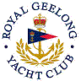 | Royal Geelong Yacht Club Inc.  Est 1859
Trophy Deed of Gift.

Trophy: | Club Captain’s Trophy
Presented by: | Life member Murray M^{c}Rae
Date: | 1999
For: | Winner- Last Race of the Season
Remarks / Revisions
Click here for a List of Recipients
